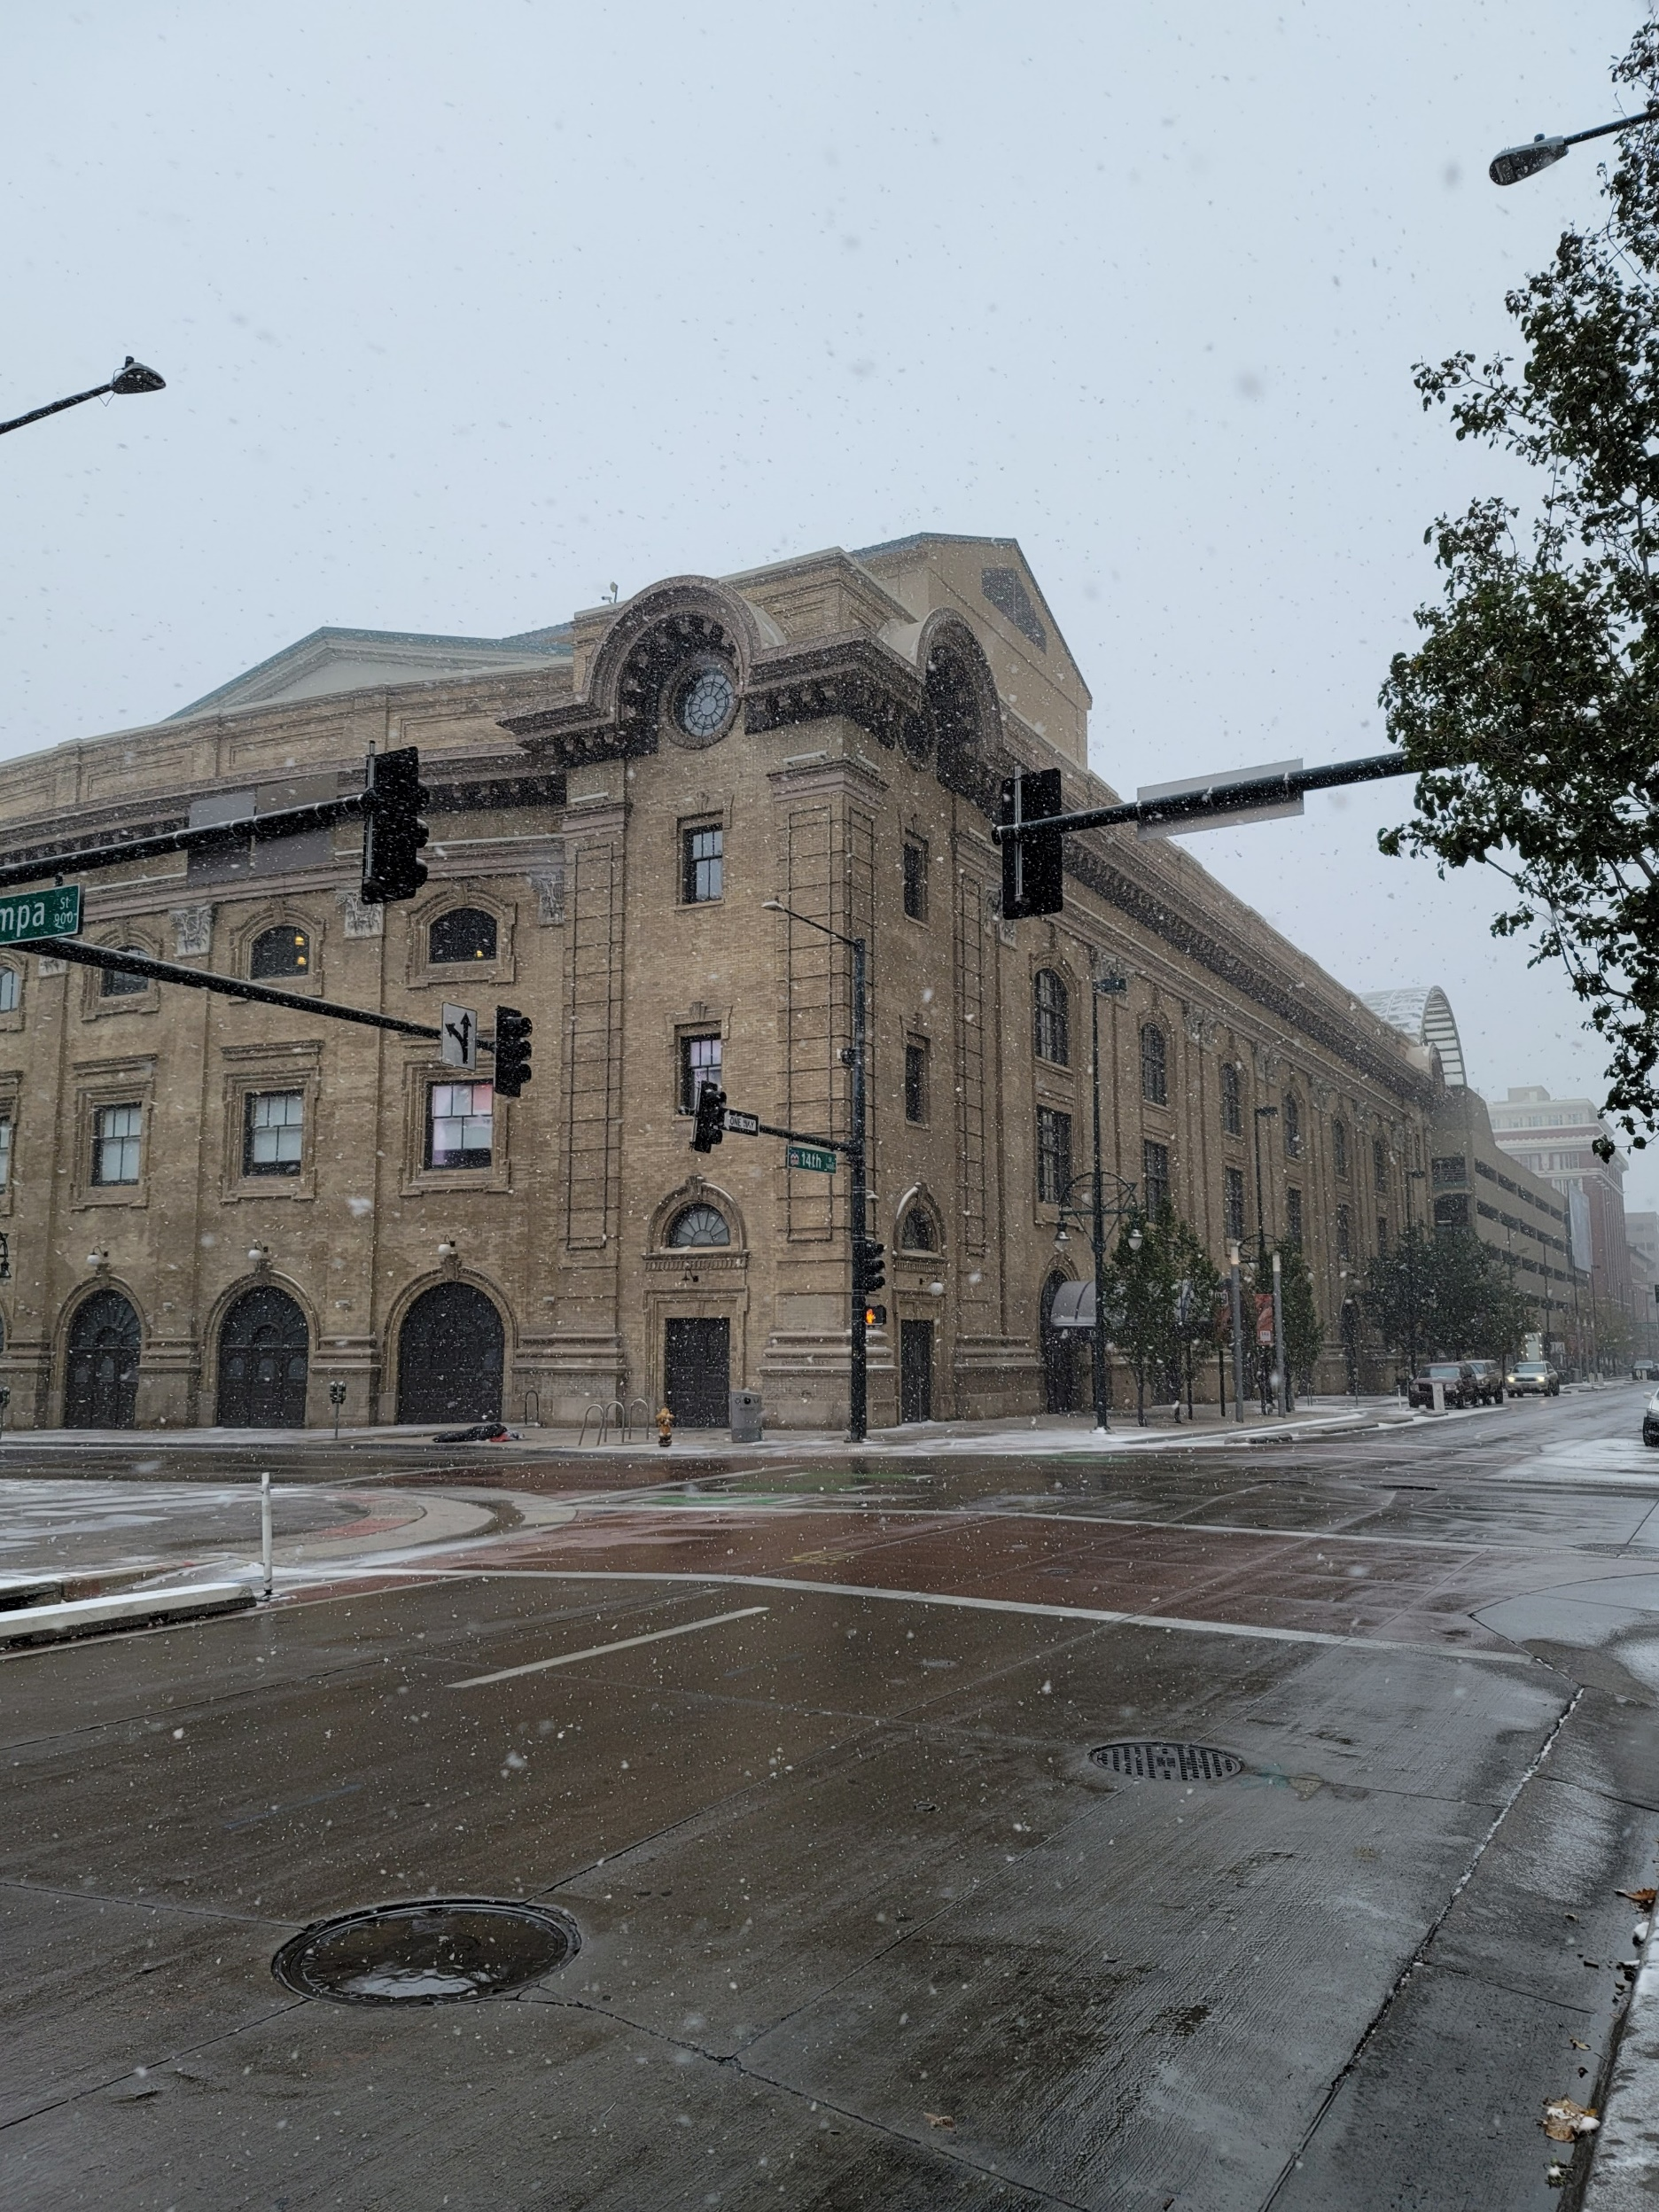

|  |
| --- |
| Bicyclist Safety in Denver County  2018 |
|  |
| Matt Burns  MSDS670 |

# Introduction

I looked at the dataset regarding vehicular accidents in Denver County from 2013 to 2023. The dataset contained information regarding three different types of accidents, motor vehicle, bicycle, and pedestrian accidents. Using Jupyter Notebook and software libraries Pandas, Numpy, Matplotlib, Geopandas, Contextily, and Seaborn, I wanted to answer a couple questions. First, is Denver County and the Denver Metro Area safe for bicyclists? Second, what are the most dangerous roads for bicyclists and therefore what areas can we improve on bike safety?

# Results

I started by examining the bigger picture of the dataset. Looking for any trends that in the overall data of accidents over the ten years that it examined.

Figure 1.

In figure 1 there are two major takeaways that pop out at the viewer. First is that from 2013 to early 2020, vehicular accidents were on the rise each year with expected ebb and flow. Second, the COVID-19 pandemic in earl 2020 severely changed the number of accidents for the better. We can also see that, thankfully, accidents have not returned to pre-pandemic numbers. Logically, the white-collar jobs of downtown more easily transitioned to remote work so we are seeing less cars on the road, thus less car accidents.

Next I wanted to focus in on vehicular accidents involving bicycles specifically. I plotted a heatmap to examine on a grander scale where these accidents are taking place.

Figure 2.

In figure 2, the information we can glean is that Downtown Denver is a dangerous place for everyone, bicyclists, vehicles, and pedestrians. Outside of downtown itself, we can see natural lines forming of increased accidents along major roads. Let’s take a closer look at what areas specifically are seeing the most bicycle accidents.

Figure 3.

Above are the top 10 areas where the highest number of bicycle accidents occur. Takeaways from the visualization are, E 16th Avenue, the most dangerous area, is one block north of E Colfax, the fourth most dangerous area. 15th Street, the second most dangerous, is a major road and connection to West of I-25 neighborhoods. This would make sense for those that bought or rented a house close to downtown in order to commute via bike. S Colorado Boulevard, the third most dangerous, is a major intersection for vehicles and bicyclists as it also includes the Cherry Creek Trail, a popular biking route downtown.

Finally, let’s examine the dangers of being involved in a bike accident in Denver County.

Figure 3.

When plotting this data, I did not include ongoing investigations or undisclosed injuries/fatalities which were listed instead of number of injured or dead. Of this dataset, 0.8% of all bicycle-related vehicular accidents ended in death. While 12.2% of the accidents ended in serious injuries.

# Conclusion

This was a fascinating dataset that gave a lot of insight into not just bicycle safety in Denver County, but also safety at large. The big takeaways I found were, accidents have dropped significantly from pre-pandemic times and don’t seem to be trending back quickly. There are clear areas of Denver County that are the most dangerous for bicyclists. However, we can see these as points of improvement for the city/county to better keep bicyclists safe on the road. In the meantime, bicyclists should avoid the areas listed in Figure 3, especially the areas of around E Colfax and 15th Street.